**DAILY ONLINE ACTIVITIES SUMMARY**

|  |  |  |  |  |  |  |  |  |
| --- | --- | --- | --- | --- | --- | --- | --- | --- |
| **Date:** | **06/06/2020** | | | | | **Name:** | **Pratibha Shetti** | |
| **Sem & Sec** | **IV sem & B section** | | | | | **USN:** | **4AL18CS062** | |
| **Online Test Summary** | | | | | | | | |
| **Subject** | | **Data Communication** | | | | | | |
| **Max. Marks** | | **30** | | **Score** | | | **26** | |
| **Certification Course Summary** | | | | | | | | |
| **Course** | **Marketing Foundation** | | | | | | | |
| **Certificate Provider** | | | **Greatlearning academy** | | **Duration** | | | **2.25 hours** |
| **Coding Challenges** | | | | | | | | |
| **Problem Statement1:** Write a program in C to rotate an array by N positions.  **Problem Statement2:** Write a Java Program to find the second-highest number in an array. | | | | | | | | |
| **Status: Executed** | | | | | | | | |
| **Uploaded the report in Github** | | | | | **YES** | | | |
| **If yes Repository name** | | | | | <https://github.com/pratibhashetty-123/Lockdown-coding-java>  <https://github.com/pratibhashetty-123/Lockdown-coding-for-C> | | | |
| **Uploaded the report in slack** | | | | | **YES** | | | |

Online Test Summary: DC test was scheduled from 9:30 am t0 10:15am .The portion for the IA was 2nd module there were 30 questions and the time assigned was 45 minutes the questions were mcq type.

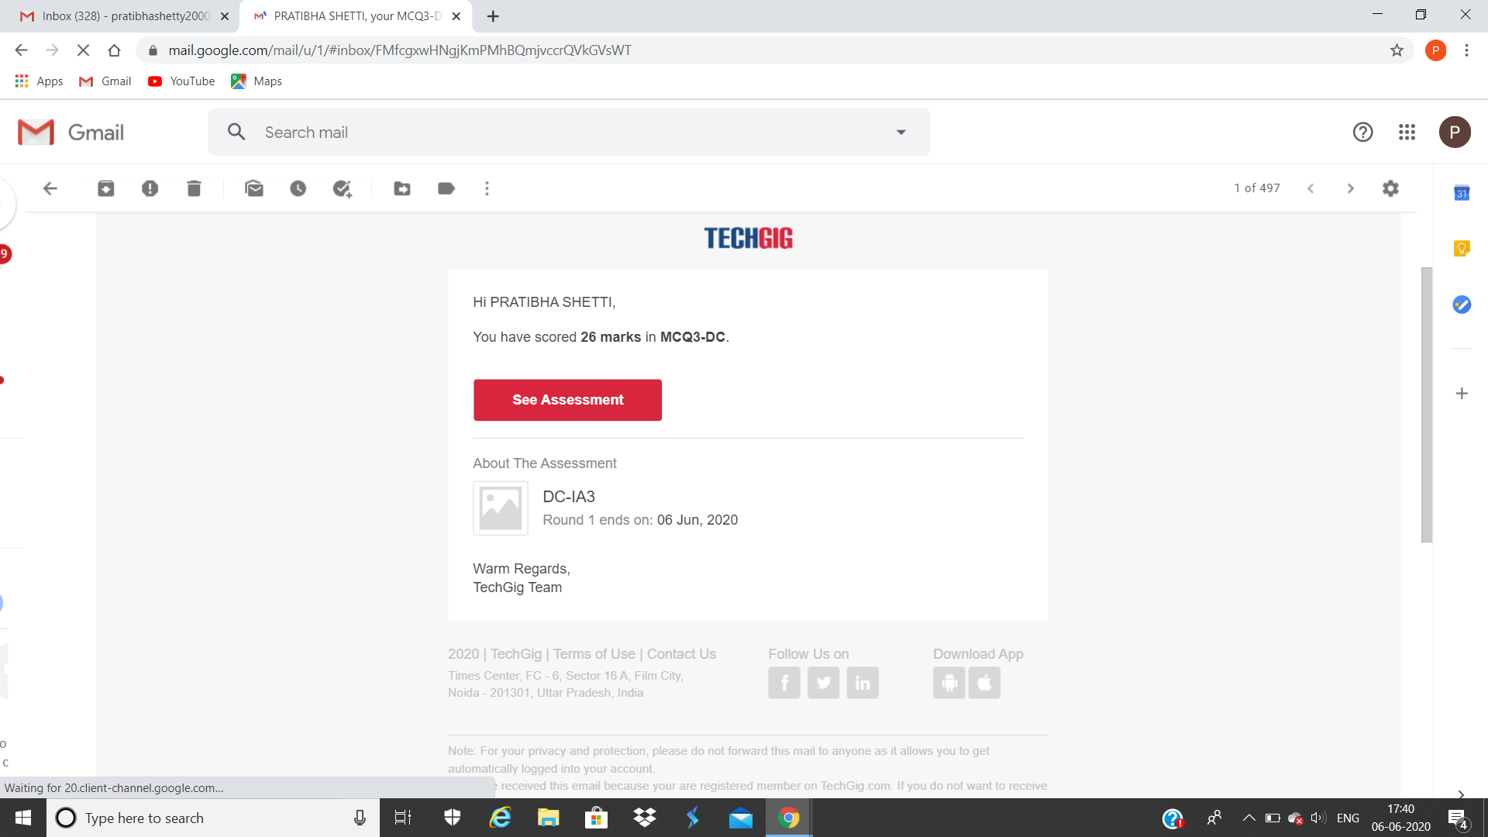

This is the snap shot of completion of test and the marks obtained.

Online Certification Course Summary: this is may new course in this course I have learnt about marketing _mix and plan implementation .



These are the snap shots of today’s session.

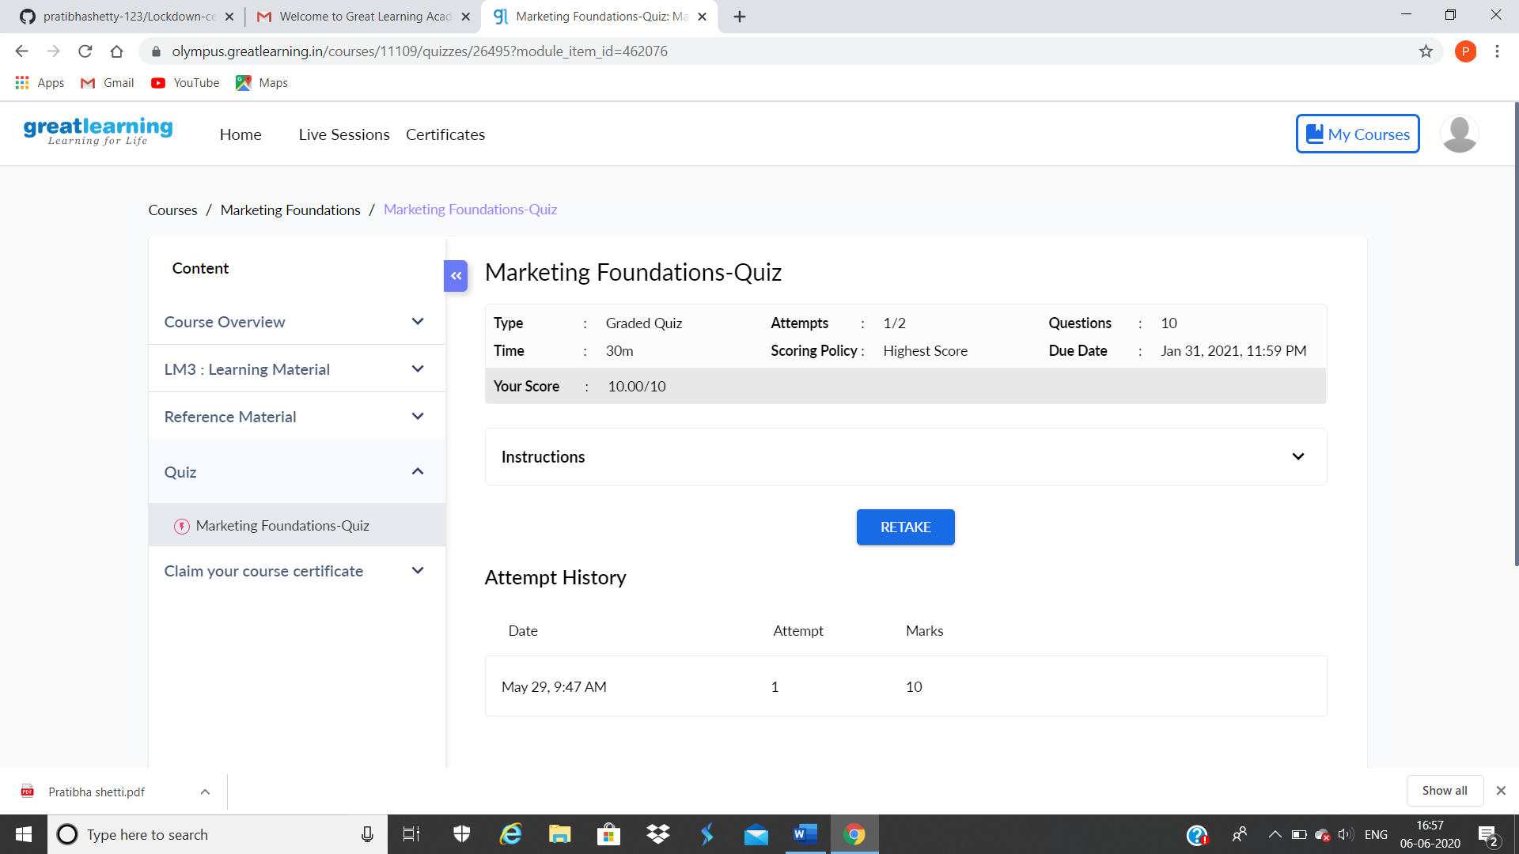v

This is the snap shot of the Quiz attempted and the grade obtained.

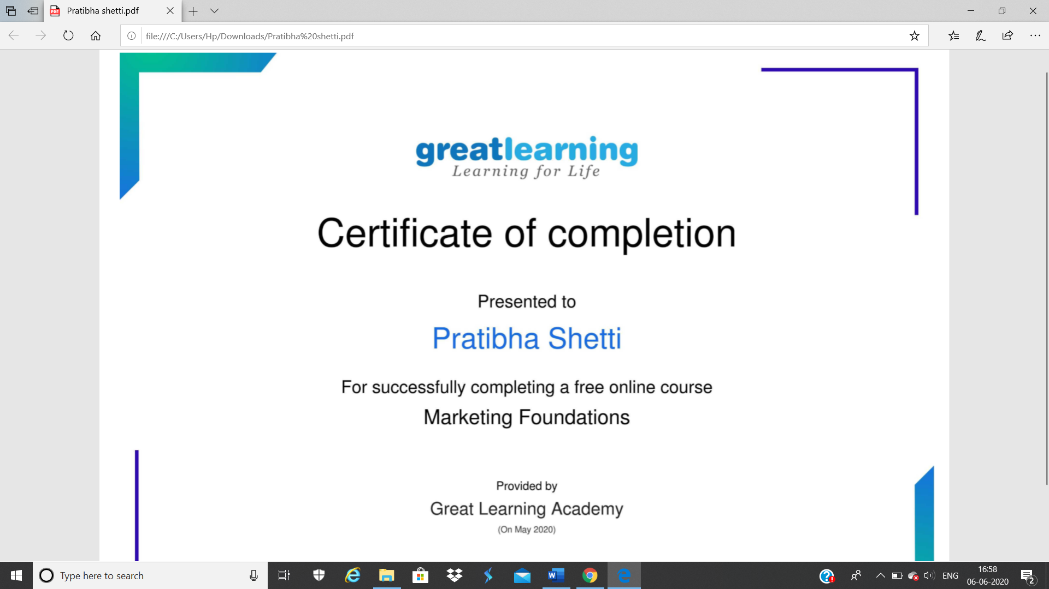

This is the certificate of completion after attending the Quiz.

Online Coding Summary:

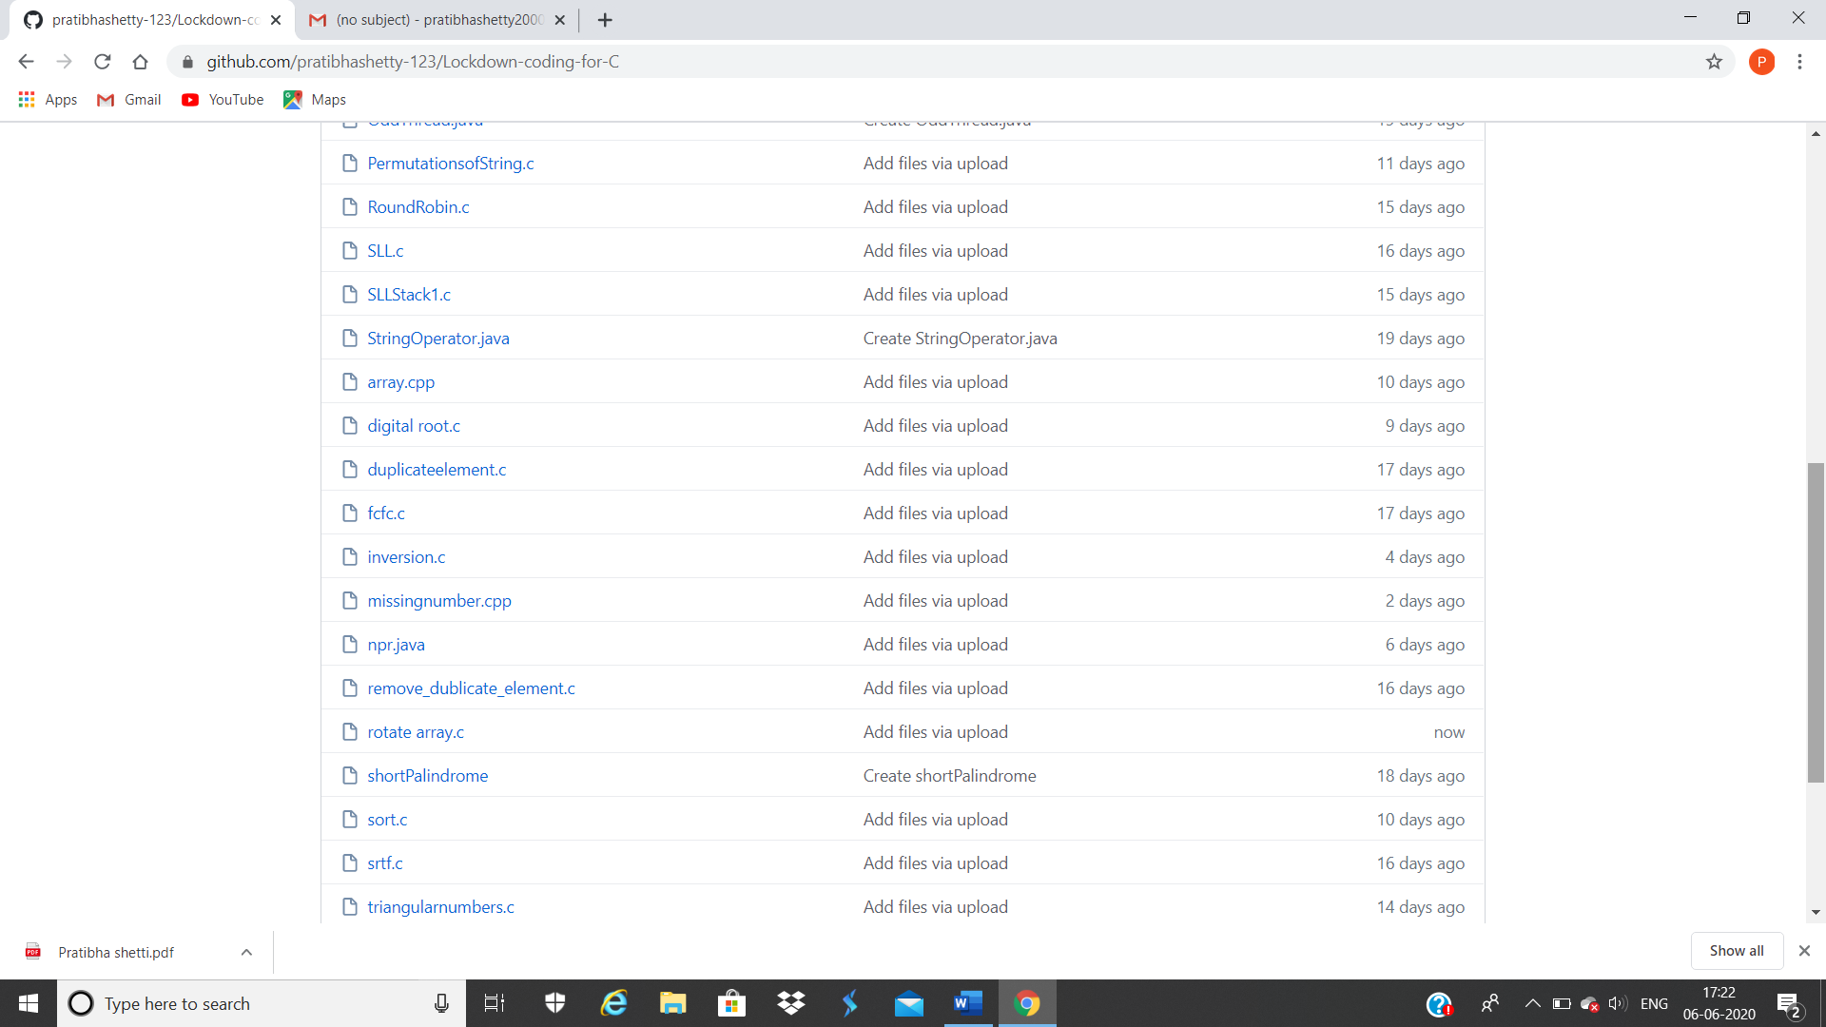

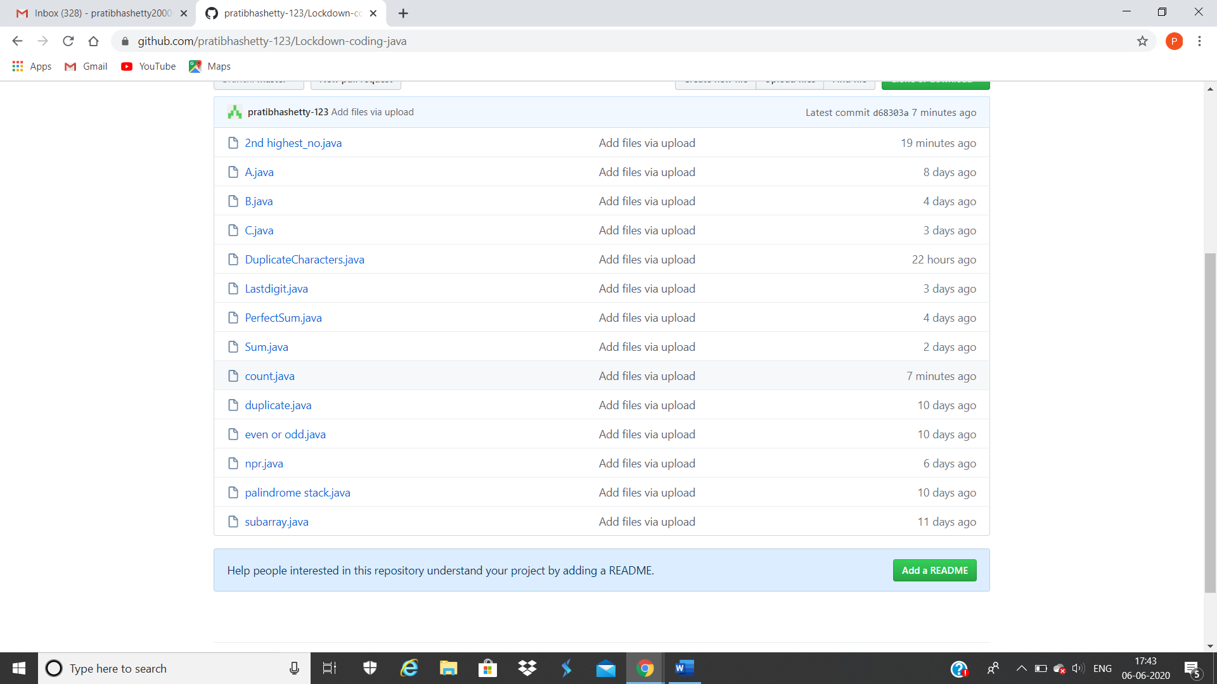

**These are the snap shot of my Github repository** were I have uploaded the code. File name is rotate array.c ,count.java and 2highest_no.java